ED6001 – MEDICAL IMAGE ANALYSIS- MINI PROJECT



GROUP_MEMBERS
1.duen Michael chombo id24m803
2.harepriya ED20BO3
3.Tegsemen

1. Problem Definition & Dataset

Problem Statement
Lung cancer remains the leading cause of cancer-related deaths worldwide, accounting for millions of fatalities each year. Alarmingly, only 16% of cases are diagnosed at an early, localized stage, where the five-year survival rate exceeds 50%. However, once detected at advanced stages, the survival rate drops drastically to nearly5%. Early diagnosis is therefore critical for improving patient outcomes.
With the advent of non-invasive imaging modalities such as Computed Tomography (CT), clinicians can obtain rich information on lung tissue characteristics. This enables the development of Computer-Aided Diagnosis (CAD) systems capable of assisting radiologists by classifying lung nodules as benign or malignant, based on extracted imaging biomarkers.

Literature Context
Several studies have highlighted the potential of radiomics—the extraction of high-dimensional quantitative features from medical images to provide reproducible and objective measures of tumor heterogeneity By combining radiomics features with machine learning models, CAD systems have demonstrated improved diagnostic accuracy and consistency compared to manual radiologist assessments, which often suffer from inter-observer variability..
By combining radiomics features with machine learning models, CAD systems have demonstrated improved diagnostic accuracy and consistency compared to manual radiologist assessments, which often suffer from inter-observer variability.

Dataset Description
This project uses the LIDC-IDRI (Lung Image Database Consortium and Image Database Resource Initiative) dataset, a publicly available repository containing expertly annotated CT scans of the human thorax.
Each scan contains one or more nodules annotated by up to four radiologists, with malignancy ratings on a five-point scale (1 = highly benign, 5 = highly malignant).
After data curation, the dataset was reduced to binary labels:
- 0 – Benign (malignancy ≤ 3)
- 1 – Malignant (malignancy ≥ 4)
A total of 2,617 samples were used, each represented by 1,619 radiomic features extracted via the PyRadiomics library.

Preprocessing Steps
- CT Scan Parsing using the pylidc library to load scans and nodules.
- Radiomics Feature Extraction using PyRadiomics with a YAML-based parameter configuration.
- Merging of Binary Labels and Feature Tables resulting in a final dataset of shape (2617, 1619).
- Normalization of continuous features and handling missing values (mean imputation).
- Dataset Split using Stratified Group 10-Fold Cross-Validation to preserve patient grouping and class balance.

2. Methodology & Implementation

Model Selection
A Support Vector Machine (SVM) was selected as the primary model for classification due to its:
- Robust performance on high-dimensional datasets,
- Effectiveness in binary classification, and
- Ability to maximize the margin between malignant and benign classes.

Implementation Pipeline
- Feature Extraction:
Radiomics features (first-order, shape-based, GLCM, GLRLM, GLSZM, and GLDM) were extracted using PyRadiomics.
- Parameter Optimization:
  - A Grid Search was conducted to identify the best hyperparameters for the SVM model (kernel, C, gamma).
  - The optimal configuration was selected based on cross-validation accuracy and recall.
- Cross-Validation Strategy:
  - Applied Stratified Group 10-Fold Cross-Validation, ensuring that:
    - Each fold maintains class distribution (benign vs malignant),
    - Data from the same patient does not appear in both training and test sets.
- Evaluation Metrics:
The following metrics were computed for each fold and averaged across all runs:
  - Accuracy
  - Balanced Accuracy
  - Precision
  - Recall
  - F1-Score
  - AUC (Area Under ROC Curve)
  - Average Precision (AP) from Precision-Recall Curve
  - Log Loss
  - Hamming Loss
- Visualization:
  - Confusion Matrix to assess classification distribution
  - ROC Curve to evaluate sensitivity vs specificity trade-off
  - Precision-Recall Curve to analyze the balance between precision and recall in imbalanced settings

3. Results & Evaluation Metrics

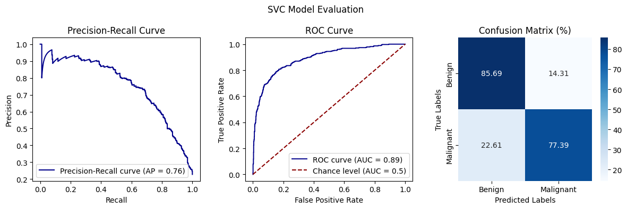

Quantitative Results
Metric | Balanced Accuracy (Scoring) | Recall (Scoring)
AUC | 0.89 | 0.87
Average Precision (AP) | 0.75 | 0.73
Accuracy | 0.83 | 0.80
F1-Score | 0.77 | 0.74
Recall | 0.78 | 0.81
Precision | 0.76 | 0.71

Qualitative Analysis
- With balanced accuracy scoring, the SVM classifier achieves high discrimination capability between benign and malignant nodules, as reflected by an AUC of 0.89.
The confusion matrix shows that most benign nodules are correctly classified, while only ~23% of malignant cases are misclassified.
- Under recall-based scoring, the model becomes more sensitive to benign cases, slightly sacrificing overall precision.
The AUC and AP decrease marginally, suggesting a trade-off between minimizing false negatives and maintaining balanced performance.

Visual Results
- ROC Curve: Demonstrates strong separation between classes (AUC ≈ 0.89).
- Precision-Recall Curve: Indicates good class balance and high model confidence.
- Confusion Matrix: Highlights effective classification of benign nodules, with controlled false positive rate.

4. Conclusion
This mini project successfully demonstrates the application of radiomics-based machine learning for lung nodule malignancy classification using CT images.
The SVM model, when optimized and evaluated using rigorous cross-validation, achieved strong discriminatory performance, making it a reliable candidate for clinical CAD systems.

